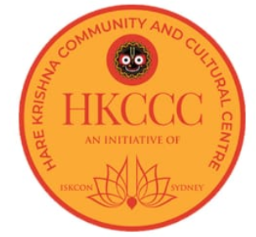 | HARE KRISHNA CULTURAL AND COMMUNITY CENTRE (HKCCC)  International Society for Krishna Consciousness  Founder-acharya: His Divine Grace A.C. Bhaktivedanta Swami Prabhupada
 |  | Yoga Waiver Declaration
 |  | (fill out one per person attending)
- Yoga involves the use of physical postures, movements and breathing techniques. As with any physical activity there is always an inherent risk of injury which could even be serious and disabling. Every effort will be made to highlight the risks involved and alternatives provided. However the risk cannot be entirely eliminated.
- If you experience any discomfort, pain or uneasiness at any stage please listen to your body, come out of the position, take rest and breathe smoothly. Let the instructor know and appropriate support will be provided.
- Yoga is not recommended under certain medical conditions. These will be discussed during the session and alternatives provided. Please follow the instructions carefully.
- If you are pregnant or are post-natal or post-surgical, your signature verifies that you have your physician’s approval to practise.
- By signing this form you assume full responsibility for any damages incurred during participation. You agree to irrevocably release and waive any claims that you may have now or hereafter against HKCCC, it’s personnel, all related facilities and premises for any personal injury or negligence. Additionally, the facility, instructor and HKCCC are not in any way responsible for any loss or damage of your personal property.
- Yoga is not a substitute for medical attention and treatment. You affirm that a licensed physician has verified that you are in good health and physical condition to participate in a yoga program, if required.
- Those under 18 years of age must have this form signed by a parent or guardian.
- You have carefully read and fully understand and agree to the above terms of this Liability Waiver Agreement.

Signature : ______________________ Date & Place :_______________________

Full Name : ________________________________________

